important information
for season 2026
Please note that this document is a live document and
will be updated as and when required throughout the season

This document provides information under the following headings:

- Darwin Netball Association

Who are the DNA Management Team?

Territory Netball Stadium
- Important Information relating to the DNA Competition
- Where is the DNA Management Office located?
- Where is the Sports Medic located?

When does the Darwin Netball Season commence?

Season 2026 Dates to Note

How do I join a club?

What are the DNA registration costs?
- Why isn’t a whole of Season Draw sent out?
- How do I register?

Why do I pay a gate fee?

When and where are trainings?

Club Presidents Meeting

Umpiring Committee
- Code of Conduct

Umpiring issues during game days
- Complaints Handled by On Court Umpires During a Match
- Complaints Handled by Club to Club
- Complaints Handled by DNA

All Abilities Netball Competition

No More Spirit Award for Premier League

Non-Playing Children in the Territory Netball Stadium
- Social Media and Communication

Where am able to walk on the inside courts?

Where am able to walk on the outside courts?

Darwin Netball Association
The Darwin Netball Association (DNA) is non profit organisation and is managed by a Management Team of volunteers. The DNA email account and office are not attended during business hours during the Dry Season Competition (March - September) and only adhocly during the Wet Season Competition (October – December) and off season (December – March).

There is a minimum response time of 72 hours on receipt of emails.

Darwin Netball Association
Street Address: 235 Abala Road
MARRARA NT 0812
Postal Address: 235 Abala Road
MARRARA NT 0812
ABN: 69 743 109 552
Office Phone: 8927 8877
Email: Darwin.Netball@gmail.com
Website: https://www.darwin-netball.com
Facebook: Darwin Netball Association Incorporated
Instagram: darwin_netball

Who are the DNA Management Team?
President Debbie Barnes
Vice President Taylah Godwin
Treasurer Thea Pearse
Development & Coaching Coordinator Vacant
Umpire Coordinator Linda Parnham
Players Representative Gabby Sutton
General Member Sandy Mackintosh

Who supports the DNA Management Team?
Administration Manager Teuila Te Aho

Job Descriptions for the above positions are located on the DNA website at About, Management Team. Each position is for a two year term and they are staggered appointments to ensure that there is consistency of representation from one year to the next.

Territory Netball Stadium

Netball NT are the managers of the Territory Netball Stadium and not the DNA as we pay a per court fee.

On DNA game nights the responsibility to clean and keep the toilets stocked lies with Netball NT.

Important Information relating to the DNA Competition
https://www.darwin-netball.com/document/ provides all of the links to the important relevant information available for players, coaches, spectators and Club members.

- By-Laws
- Code of Conduct Policies
- Complaint Incident Form and Procedure
- Constitution
- DNA Policies
- DNA Competition Regulations

Where is the DNA Management Office located?
The DNA Management Office is located on the outdoor courts next to the food kiosk. There is a window access so that people can speak with the DNA volunteers if they have any issues.

The green circle below indicates where the office is located.
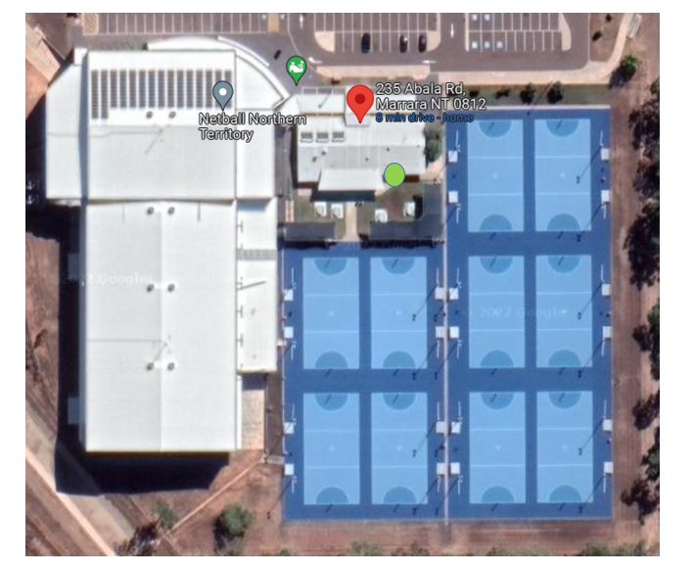

Where is the Sports Medic located?
The Sports Medic on game days can be located in two places as marked below with red crosses.
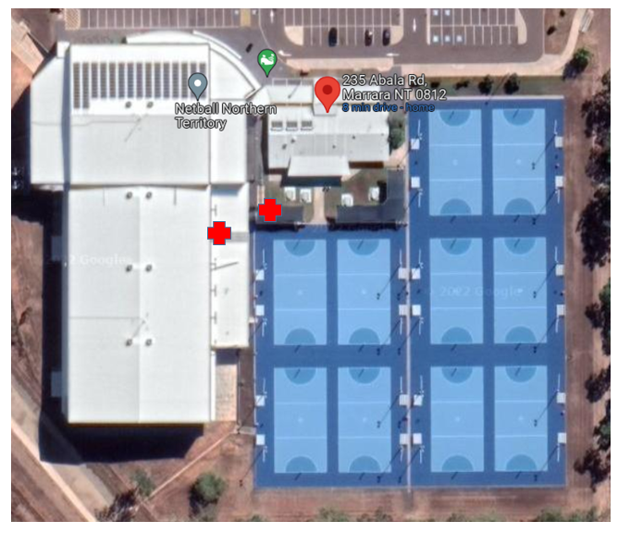

When does the Darwin Netball Season commence?
Darwin Netball has two Seasons – Dry (competitive) and Wet (social).

The Dry Season Competition for Senior Womens and Senior Mens commences in April (Thursday nights) with time slots of 6:00pm, 7:30pm and 9:00pm. Juniors and Mixed commences in April (Wednesday nights) with time are 5:25pm, 6:40pm and 7:45pm. Both competitions run until September with a break in the June/July school holidays. Preliminary, semi and grand finals held for both the Senior and Junior competitions.

Late January 2026, the DNA MT promotes and advises via email to Club Presidents, Facebook and Instagram will provide confirmation of the Dry Season start dates for the senior, junior and mixed competitions.

The Wet Season Competition is a social eight week competition that runs from October – December on Thursday nights with time slots of 6:00pm, 7:00pm and 8:00pm. Teams provide their own umpires, scorers, balls and bibs. There is A Grade, B Grade, C Grade and mixed teams. There is no preliminary, semi or grand finals held.

Late September 2026, the DNA MT promotes and advises via email to Club Presidents, Facebook and Instagram will provide confirmation of the Wet season start date.

Season 2026 Dates to Note
Seniors
- Premier League Season starts 2 April 2026
- Mens, Division 1
to Division 5/6 Season starts 2 April 2026
- Semi-finals 20 August 2026
- Prelim finals 27 August 2026
- Grand final 4 September 2026

Juniors and Mixed
- Season starts: 15 April 2026
- Semi-finals: 19 August 2026
- Prelim finals: 26 August 2026
- Grand finals: 2 September 2026

How do I join a club?
Head to our website www.darwin-netball.com under the Clubs Tab and contact the clubs directly.

The current affiliated clubs in alphabetic order are:
- Banks Bulldogs
- Cougars
- Litchfield Bears
- Mash
- Nightcliff Tigers
- Pints
- Southern Districts Crocs
- Tracy Village Falcons
- Waratah

What are the DNA registration costs?
Netball NT charges the DNA for each player registration – for 2026 $85.50 per senior player and $80.59 per junior player. This cost is then incorporated into the DNA player registration fee. DNA always tries to limit the impact of the Netball NT fees and have for the past 10 years and have never passed on the full increase. From 2025 DNA has had to increase due to Netball NT increasing the player registration and court hire fees.

Dry Season 2026
NetSETGo $155
Juniors $150
Seniors $170

Please note that all clubs incorporate the above Netball NT/DNA registration fee into their own club fees. This is then paid directly by the player/individual.

Wet Season 2026
Non registered player $100
Dry Season registered player $75

Why isn’t a whole of Season Draw sent out?
A whole of season draw is not sent out as there are usually multiple changes in the first half of the season due to team movements. To ensure that all senior teams have the opportunity to play at every timeslot the DNA extends every effort to ensure that the late timeslot is spread evenly across all teams in each Division.

The DNA promotes any changes via email to the clubs and on our Facebook page.

If one of your coaches notices some errors in the draw, please advise your club who will liaise with the DNA to review and rectify if required.

How do I register?
Netball Connect is the technology platform that has been adopted by Netball NT to provide the netball community with an efficient, user-friendly experience to manage, score, play and spectate. Netball Connect has a multitude of features including:

Registration: With the ability to register multiple competitions.
Game Day App: With real-time scoring, verification, recording and rostering, it aims to reduce resources required for game day planning.
Competition Management: With the ability to reduce the time required for draws from weeks to minutes.

Why do I pay a gate fee?
DNA asks you to pay a gate fee entry on game nights as the Territory Netball Stadium is managed and maintained by Netball NT.

Netball NT charge DNA a hire fee for using the indoor courts, outdoor courts, lights, electricity, air conditioning, water and ablutions.

Due to a lack of volunteers, the DNA has been required to employ casual staff in positions such as the Administration Officer and Match Day Supervisor. The gate fee is put towards funding these positions.

Netball NT charges the DNA $66 per hour per indoor court and $28 per hour per outside court. The gate fee goes towards court hire, subsidising representative teams, development programs, NT Link teams, grand final medals/towels.

Gate Fees 2026 (Cash/EFTPOS/Gate Passes)
All ETFPOS transactions will incur a $0.10 surcharge
Senior Player $5
Junior Player $3
Spectator $2 (15 years and under free if accompanied by a paying adult)
Season Pass $105 Individual (24 entries including 21 games and 3 final games)
Season Pass Family Junior $75 (1 player, 1 adult)
Season Pass Family Junior $120 (2 Players, 1 Adult)

Please contact DNA if you require other options.

Children under the age of 16 years will be denied entry to the Territory Netball Stadium unless accompanied and supervised by an adult.

The entry gate/foyer is located inside the Territory Netball Stadium. Please refer to the yellow triangle below.
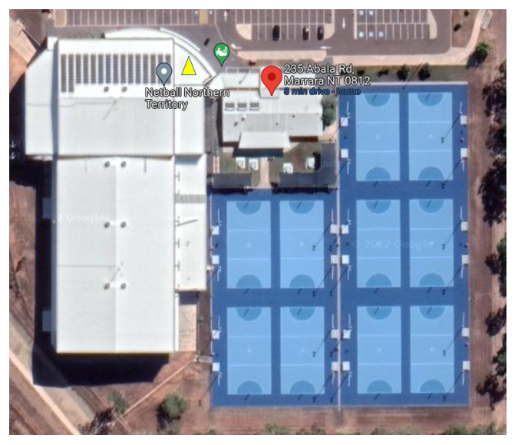

When and where are trainings?
Trainings are Monday and Tuesday evenings at Marrara Netball courts. Clubs arrange directly with Netball NT on the day and time. Clubs pay Netball NT directly for the cost of the use of the courts. Contact your club to find out what date and what time is relevant to you. Some clubs do train at different locations i.e.. Palmerston Netball Courts.

Netball NT contact details:

Territory Netball Stadium
235 Abala Road
MARRARA NT 0810
(08) 8945 1733
office@netballnt.org.au

Postal Details:
PO Box 2391
PARAP NT 0804
https://nt.netball.com.au/contact

Club Presidents Meeting
To provide an opportunity for the DNA Management Team and Club Presidents to come together to collectively share/generate ideas/information and discuss different perspectives of issues that have arisen during the season competition. The meeting is to improve and streamline the DNA competition by ensuring that all Clubs are aware and understand the requirements that the DNA competition is required to run within both Netball NT and Netball Australia’s directions.

The DNA President is the Chair of the meeting. All DNA Management Team members attend the meeting.

Umpiring
Darwin Netball Association Umpires are made up of badged umpires ranging from A to C and has well over 150 years of umpiring knowledge between the members and varying experience from National level to grass roots. Under the direction of the DNA Management Team the committee looks at streamlining the payment and allocation system regarding umpires across the DNA competition. It also facilitates and conducts information sessions throughout the season regarding rules, encouraging coaches, players and umpires to be a part of. A number of programs that are offered to identified umpires, providing umpires the chance to improve their skills in umpiring with the goal of achieving higher badges. Another element of this program is to ensure that there are mentors guiding those in the talent programs, and careful consideration is given when appointing mentors to the program.

The DNA Umpire Coordinator organises the umpire allocations each week. If the DNA umpires are unable to fill the umpiring slots, then the requests are sent to clubs to provide an umpire.

Code of Conduct
The DNA is committed to providing a safe environment for the participation and attendance of all people during the netball season. The DNA Management Team has a zero tolerance for bringing the DNA competition into disrepute with abusive (verbal and physical) and disrespectful behaviour.
Please refer to the DNA Code of Conduct Offences Policy which applies to all registered members and non-members of the DNA competition.

Umpiring issues during game days
If there is an issue in relation to umpiring or on court behavior during a match, a club member is able to come to the DNA Management Office and request that an Umpire Coordinator attend the match to supervise/review the situation.

All Abilities Netball Competition
The All Abilities Program is focused on providing more sporting and recreational opportunities for people living with a disability. The program usually runs for 10 weeks and involves games and skill sessions. This competition plays an important role in encouraging people in our community to engage in sporting activities which supports positive mental health and improves social skills along with promoting physical health.

No More Spirit Award for Premier League
The No More Spirit Award for Premier League is in relation to Charlie King’s NO MORE Campaign and the NT News Sport. Each week the player that displays being the most supportive, has spirit, demonstrates sportsmanship at its highest level and behaviour towards umpires and opposition on court. The Premier League umpires vote for the two players on court that epitomizes the Spirit Award.

Non-Playing Children in the Netball NT Facility
The DNA requires all clubs, parents, members and visitors to actively supervise their child/children at all times while present at the Netball NT Territory Netball Stadium.

Children are not allowed to run up and down the stairs in the indoor Territory Netball Stadium.

Please refer to the DNA Non-Playing Children Policy.

Please note that for the Junior Competition on Wednesday nights the DNA has employed a DNA Match Day Supervisor for the season. The DNA Match Day Supervisor will be on site each Wednesday to ensure that there is no untoward behaviour and that children are not left unsupervised and are redirected to their parents.

The DNA Match Day Supervisor Job Description is located on the DNA website at About, Management Team.

Social Media and Communication
We expect our members to conduct themselves appropriately when using electronic communication to share information with other members or posting material on public websites connected to the DNA.

Electronic communication:
- should be restricted to DNA matters
- must not offend, intimidate, humiliate or bully another person
- must not be misleading, false or injure the reputation of another person
- should respect and maintain the privacy of members
- not bring the DNA into disrepute.

Please refer to our DNA Social Media and Communication Policy.

Complaints Handled by On Court Umpires During a Match
Rules of Netball 2020 Edition https://netball.com.au/sites/default/files/2020-01/INF_NETBALL%20RULE%20BOOK%20MANUAL%202020.pdf
If an incident form is completed in relation to an incident that occurred during a match where the On Court Umpires presided and a penalty was issued, the DNA considers that the matter has been resolved and finalised and will accept the complaint for information with no further action.

Complaints Handled by Club to Club
- On court unsportsmanlike behaviour.
- On court verbal inappropriate/offensive language.
- On court aggressive behaviour.
- Behaviour or an incident that occurred at the club level or involves people operating at the club level, the complaint is to be reported to and handled by the relevant club.

Complaints Handled by DNA
Incidents may occur before, during or after the conduct of the Tournament, Competition, Activity or Event and within the confines of the Marrara Netball NT Facility excluding the carpark and surrounds.
- Abuse of an umpire.
- Gross breach of Code of Conduct.
- Online breach of Code of Conduct.
- Fighting.
- Spitting.
- Threatening a person.
- Deliberately endangering the health and safety of any player, spectator or official (incidents involving blood/body fluids)

Where am able to walk on the inside courts?
When games are in play the umpires have absolute priority access to the outside of the court. During play you are required to walk 2 meters from the base line (goal posts). You are not permitted to walk in between courts at any time during play – only where the metal seats are located:

- between court 1 and 2
- between court 3 and 4
- against the wall on court 4

This is to ensure that umpires, players and spectators are not injured.

Red line indicates where you are unable to walk during play.
Yellow line indicates that you are able to walk during play as close to the wall and seating as possible.
Pink line indicates that you must walk as close as possible to the wall during play. However , when walking behind the baseline, it is courtesy to stop and wait until a player is taking a shot OR game play is in action where the umpire requires the baseline to umpire.

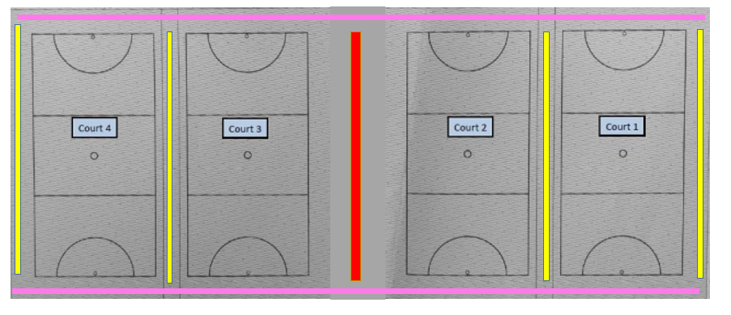

Where am able to walk on the outside courts?
When games are in play the umpires have absolute priority access to the outside of the court. During play you are required to walk 2 meters from the base line (goal posts). You are not permitted to walk in between courts at any time during play – only where the metal seats are located.

This is to ensure that umpires, players and spectators are not injured.

Red line indicates where you are unable to walk during play.
Yellow line indicates that you are able to walk during play.
Pink line indicates that you must walk as close as possible to the wire fence during play.
